1. Write a C program to simulate SJF scheduling algorithm non preemptive.
#include <stdio.h>
struct Process {
int pid, at, bt, ct, tat, wt;
};
int main() {
int n;
printf("Enter number of processes: ");
scanf("%d", &n);

struct Process p[n];
for(int i=0; i<n; i++) {
p[i].pid = i+1;
printf("Enter Arrival Time and Burst Time for P%d: ", i+1);
scanf("%d %d", &p[i].at, &p[i].bt);
p[i].ct = 0;
}
int completed = 0, time = 0;
while(completed < n) {
int idx = -1, min_bt = 9999;
for(int i=0; i<n; i++) {
if(p[i].at <= time && p[i].ct == 0 && p[i].bt < min_bt) {
min_bt = p[i].bt;
idx = i;
}
}
if(idx != -1) {
time += p[idx].bt;
p[idx].ct = time;
p[idx].tat = p[idx].ct - p[idx].at;
p[idx].wt = p[idx].tat - p[idx].bt;
completed++;
} else {
time++;
}
}
printf("\nPID\tAT\tBT\tCT\tTAT\tWT\n");
for(int i=0; i<n; i++) {
printf("%d\t%d\t%d\t%d\t%d\t%d\n",
p[i].pid, p[i].at, p[i].bt, p[i].ct, p[i].tat, p[i].wt);
}
return 0;
}
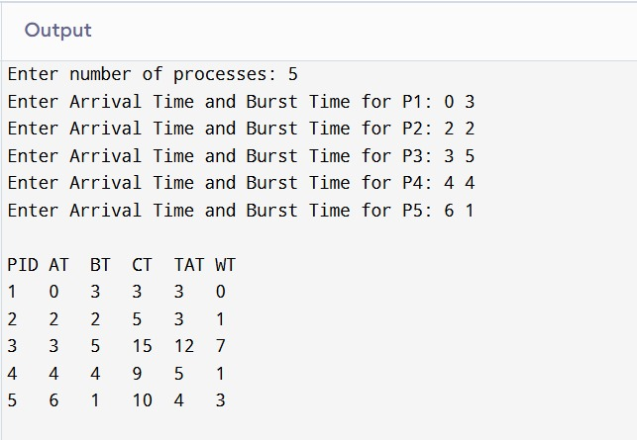

2. Write a C program to simulate SJF scheduling algorithm preemptive.
#include <stdio.h>

struct Process {
int pid, at, bt, rt, ct, tat, wt;
};

int main() {
int n;
printf("Enter number of processes: ");
scanf("%d", &n);

struct Process p[n];
for(int i=0; i<n; i++) {
p[i].pid = i+1;
printf("Enter Arrival Time and Burst Time for P%d: ", i+1);
scanf("%d %d", &p[i].at, &p[i].bt);
p[i].rt = p[i].bt;
p[i].ct = 0;
}

int completed = 0, time = 0;
while(completed < n) {
int idx = -1, min_rt = 9999;
for(int i=0; i<n; i++) {
if(p[i].at <= time && p[i].rt > 0 && p[i].rt < min_rt) {
min_rt = p[i].rt;
idx = i;
}
}
if(idx != -1) {
p[idx].rt--;
time++;
if(p[idx].rt == 0) {
p[idx].ct = time;
p[idx].tat = p[idx].ct - p[idx].at;
p[idx].wt = p[idx].tat - p[idx].bt;
completed++;
}
} else {
time++;
}
}

printf("\nPID\tAT\tBT\tCT\tTAT\tWT\n");
for(int i=0; i<n; i++) {
printf("%d\t%d\t%d\t%d\t%d\t%d\n",
p[i].pid, p[i].at, p[i].bt, p[i].ct, p[i].tat, p[i].wt);
}
return 0;
}
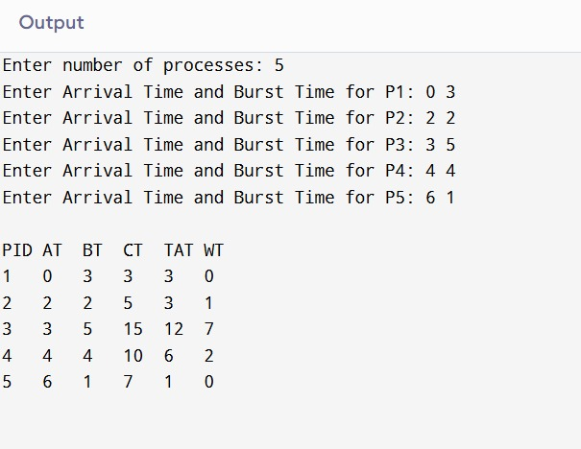

3. Write a C program to simulate priority scheduling algorithm non preemptive.
#include <stdio.h>

struct Process {
int pid, at, bt, pr, ct, tat, wt;
};

int main() {
int n;
printf("Enter number of processes: ");
scanf("%d", &n);

struct Process p[n];
for(int i=0; i<n; i++) {
p[i].pid = i+1;
printf("Enter Arrival Time, Burst Time and Priority for P%d: ", i+1);
scanf("%d %d %d", &p[i].at, &p[i].bt, &p[i].pr);
p[i].ct = 0;
}

int completed = 0, time = 0;
while(completed < n) {
int idx = -1, highest = 9999;
for(int i=0; i<n; i++) {
if(p[i].at <= time && p[i].ct == 0 && p[i].pr < highest) {
highest = p[i].pr;
idx = i;
}
}
if(idx != -1) {
time += p[idx].bt;
p[idx].ct = time;
p[idx].tat = p[idx].ct - p[idx].at;
p[idx].wt = p[idx].tat - p[idx].bt;
completed++;
} else {
time++;
}
}

printf("\nPID\tAT\tBT\tPR\tCT\tTAT\tWT\n");
for(int i=0; i<n; i++) {
printf("%d\t%d\t%d\t%d\t%d\t%d\t%d\n",
p[i].pid, p[i].at, p[i].bt, p[i].pr, p[i].ct, p[i].tat, p[i].wt);
}
return 0;
}
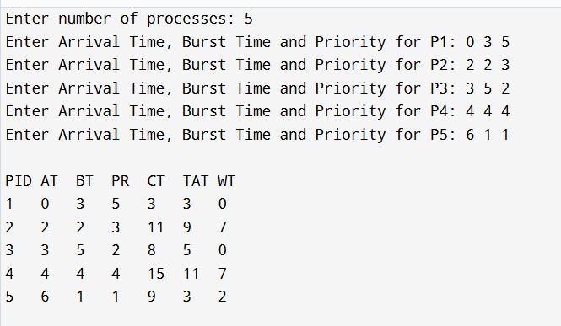
4. Write a C program to simulate priority scheduling algorithm preemptive.
#include <stdio.h>

struct Process {
int pid, at, bt, rt, pr, ct, tat, wt;
};

int main() {
int n;
printf("Enter number of processes: ");
scanf("%d", &n);

struct Process p[n];
for(int i=0; i<n; i++) {
p[i].pid = i+1;
printf("Enter Arrival Time, Burst Time and Priority for P%d: ", i+1);
scanf("%d %d %d", &p[i].at, &p[i].bt, &p[i].pr);
p[i].rt = p[i].bt;
p[i].ct = 0;
}

int completed = 0, time = 0;
while(completed < n) {
int idx = -1, highest = 9999;
for(int i=0; i<n; i++) {
if(p[i].at <= time && p[i].rt > 0 && p[i].pr < highest) {
highest = p[i].pr;
idx = i;
}
}
if(idx != -1) {
p[idx].rt--;
time++;
if(p[idx].rt == 0) {
p[idx].ct = time;
p[idx].tat = p[idx].ct - p[idx].at;
p[idx].wt = p[idx].tat - p[idx].bt;
completed++;
}
} else {
time++;
}
}

printf("\nPID\tAT\tBT\tPR\tCT\tTAT\tWT\n");
for(int i=0; i<n; i++) {
printf("%d\t%d\t%d\t%d\t%d\t%d\t%d\n",
p[i].pid, p[i].at, p[i].bt, p[i].pr, p[i].ct, p[i].tat, p[i].wt);
}
return 0;
}
